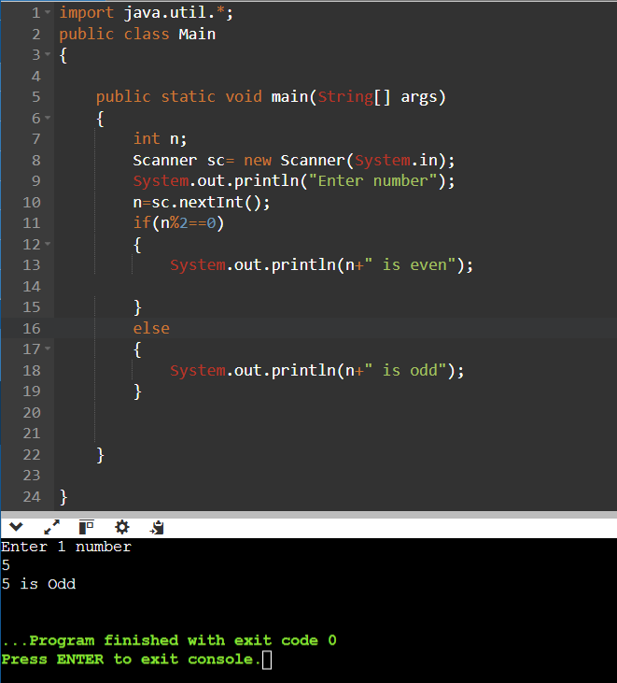Q1 WRITE A PROGRAM TO PRINT EVEN AND ODD NO

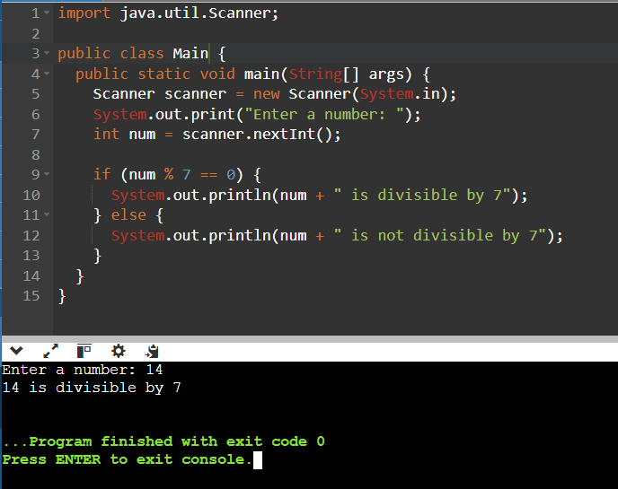Q2 WAP TO CHECK WHETHER THE NOS 7 IS DIVISIBLE OR NOT

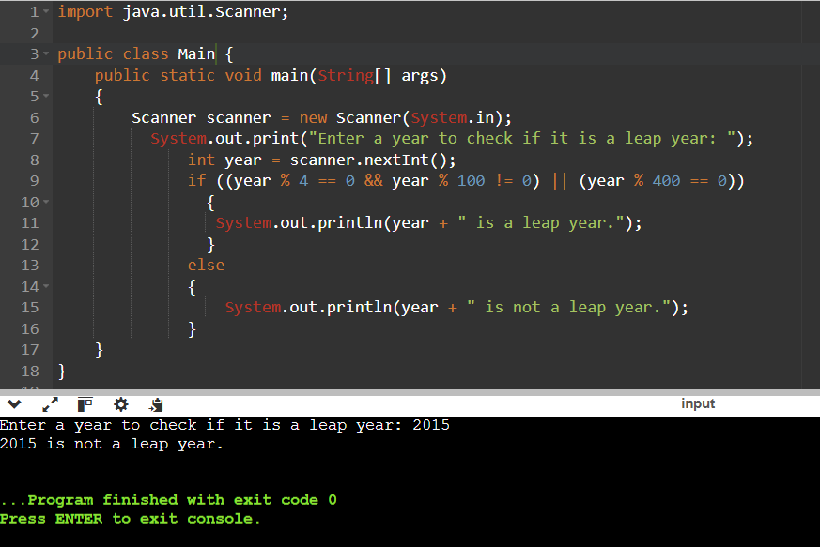Q3 WAP TO CHECK WHETHER THE NOS IS PRIME OR NOT

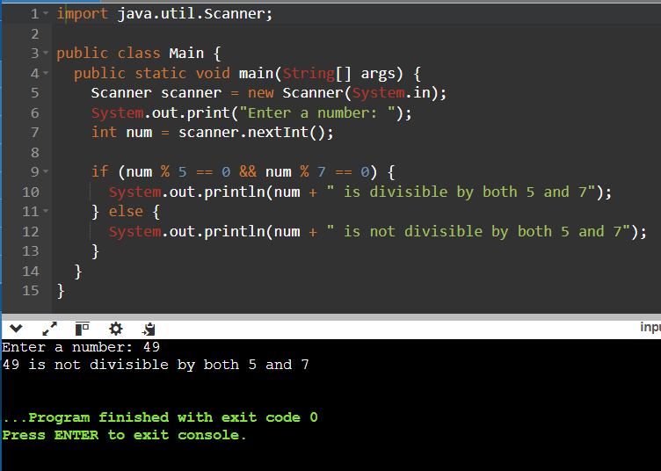Q4 WAP TO CHECK WHETHER THE NOS 7 AND 5 IS DIVISIBLE OR NOT

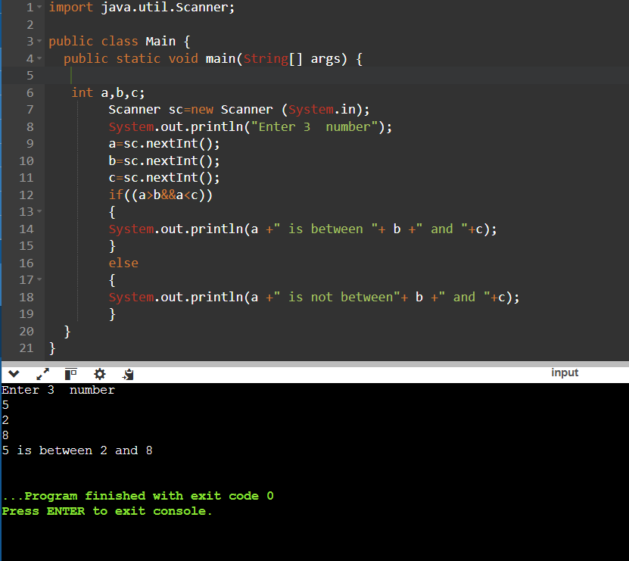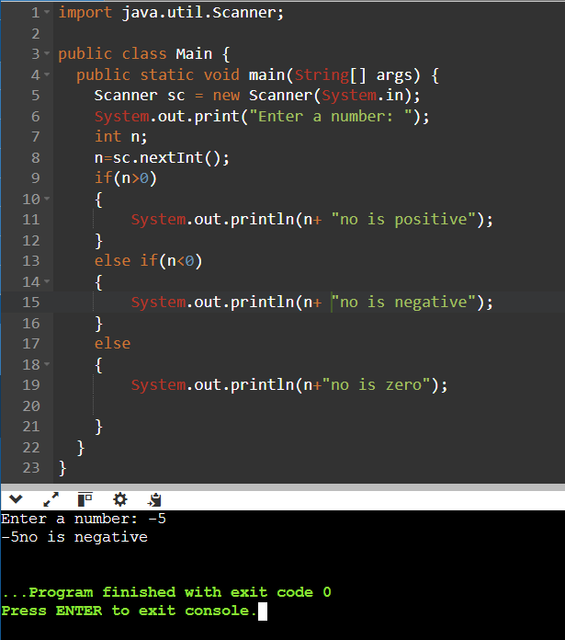Q5 WAP TO CHECK WHETHER THE NO IS POSITIVE OR NEGATIVE Q8 WAP TO CHECK THE RANGE IN BETWEEN 1ST ,2ND AND 3RD

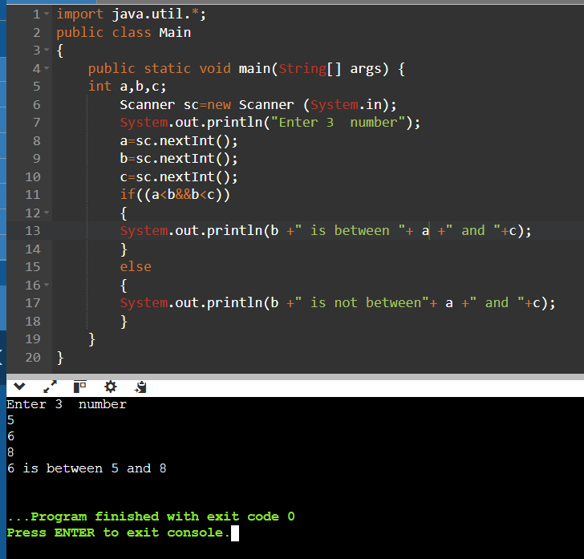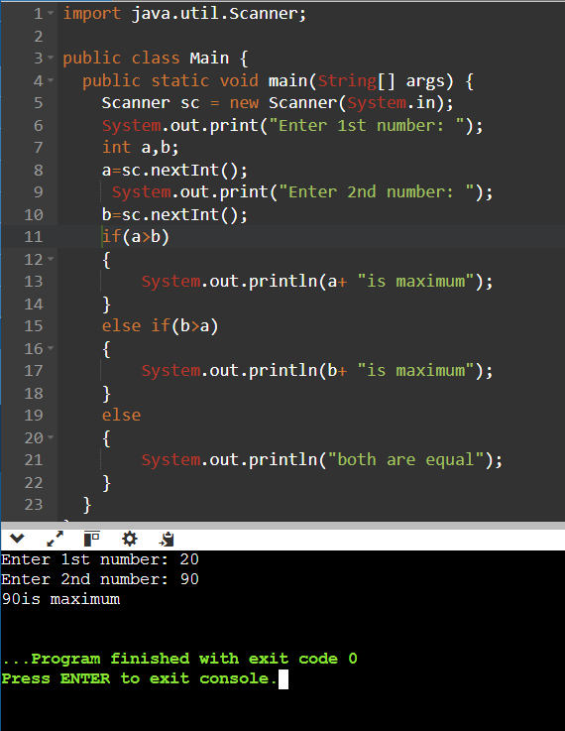Q6 WAP TO CHECK THE MAX NO BETWEEN TO TWO NOS   
 Q9 WAP TO CHECK THE MAX NO second no is between first no and third no

Q7 WAP TO CHECK THE MIN NO BETWEEN TO TWO NOS

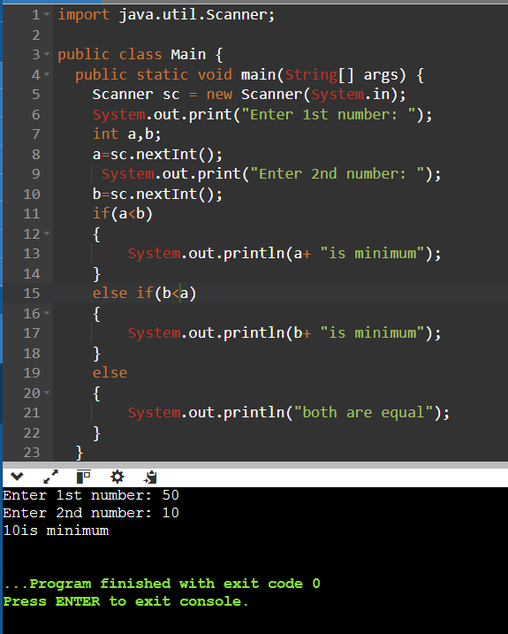

Q10 WAP TO CHECK THE MAX NO Third no is between first no and second no

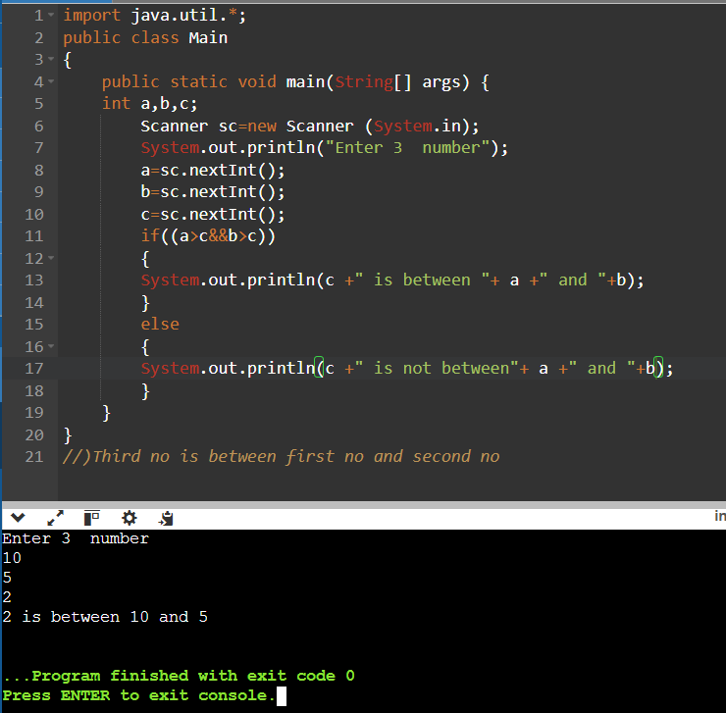

Q11 Accept selling price & cost price from user and display

profit amt or loss amt or none

(loss or profit in percentage)

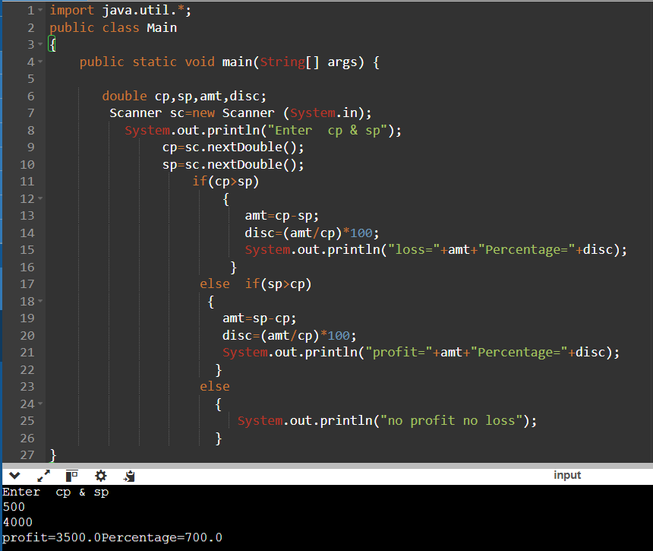

Q12 WAP TO CHECK WHETHER THE AGE IS eligibility FOR Voting OR NOT

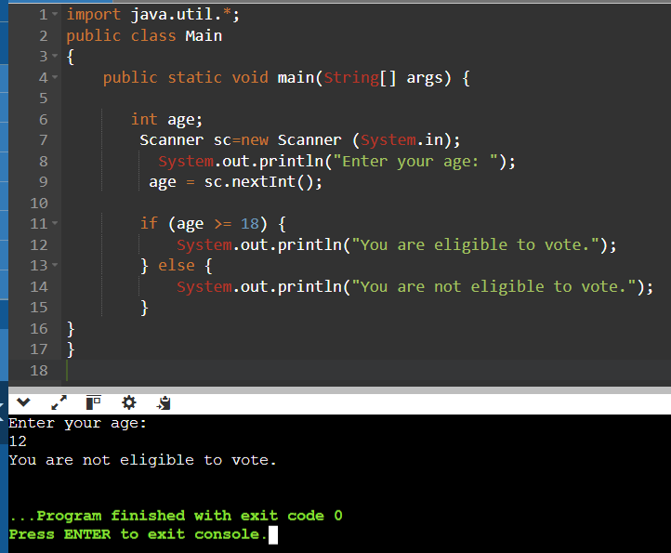

Q13 accept balance amt & withdraw amount if withdraw amount is greater than balance amt then

display msg otherwise display remaining balance after withdraw amt.

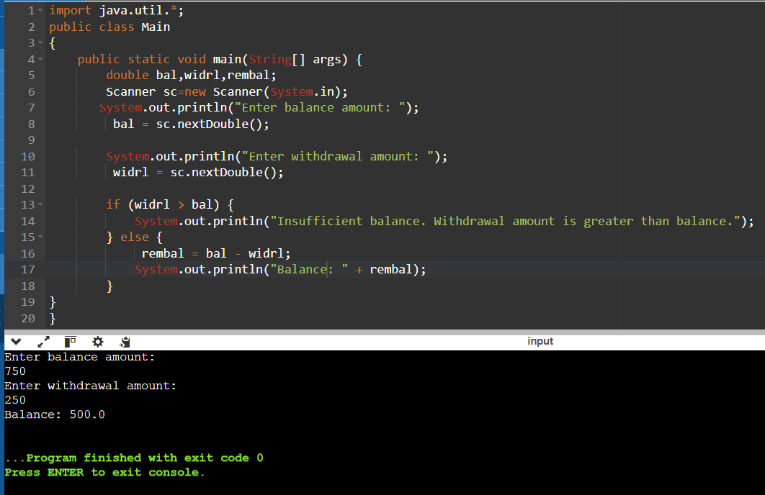

Q14 Accept no of vaccine taken & print its eligibility for interview or not

(Vaccine no=2 then eligible)

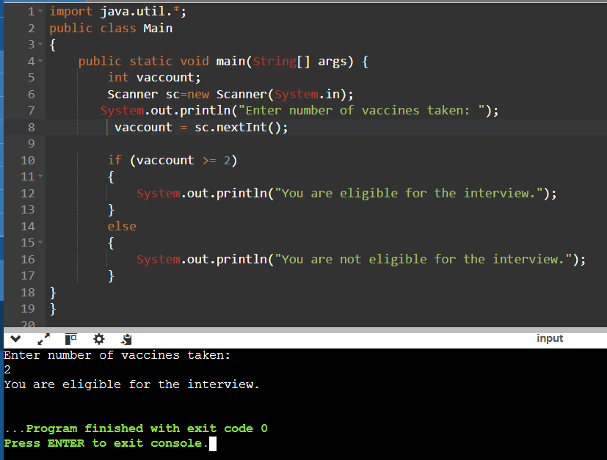

Q15 Accept atm pin from user check whether it is valid or not (1234)

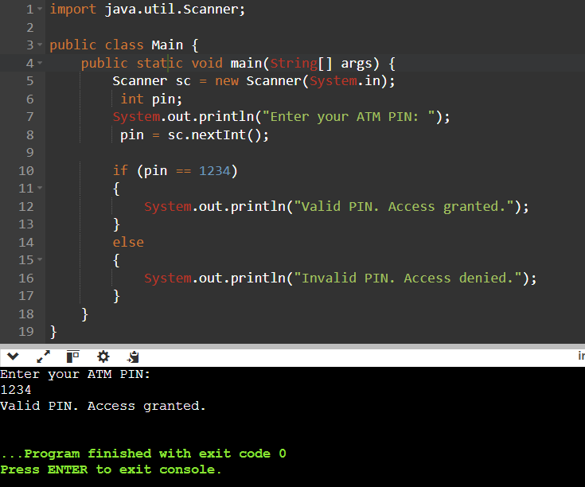

Q16 check whether no is 1 digit or 2 digit or .........

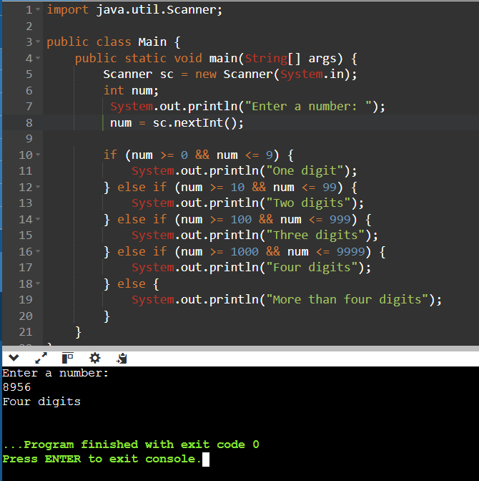

Q17 Write a program to read three sides a,b,c of a triangle and print the type of the triangle

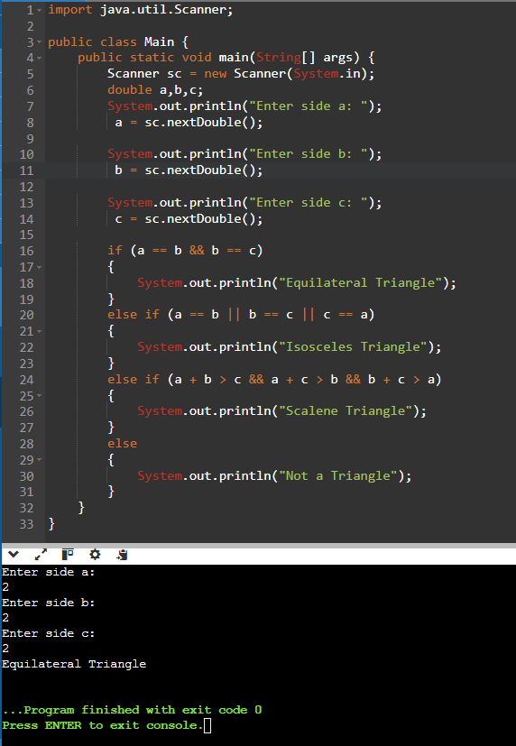

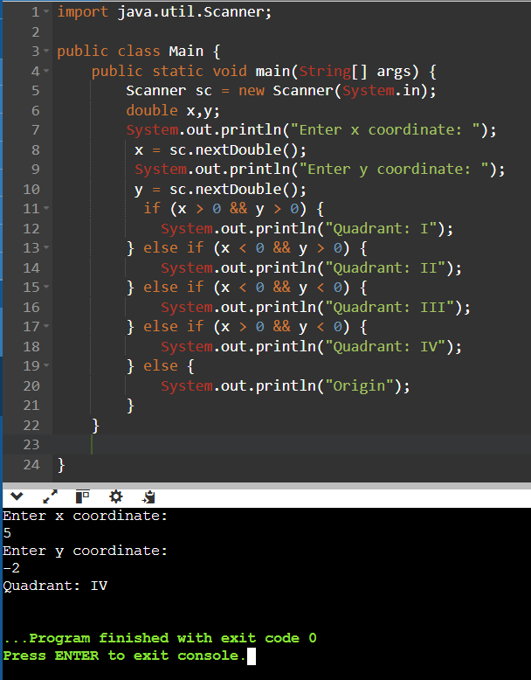Q18 Accept x & y point from user & print its quadrant